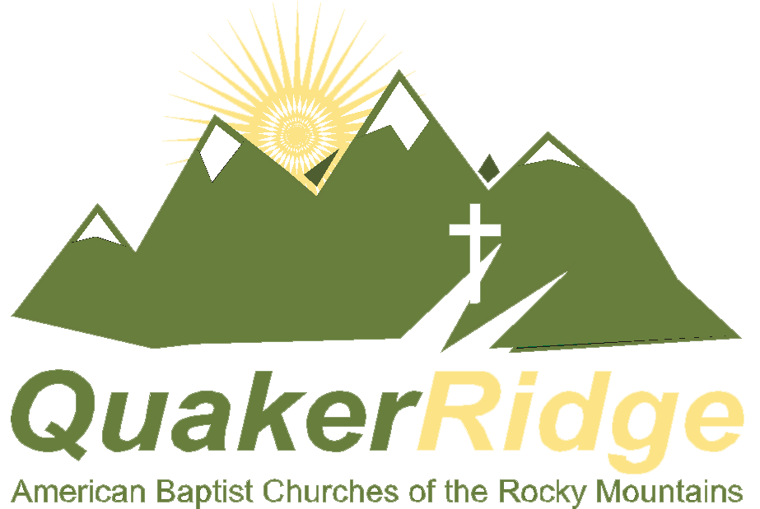
Group Leader Job Description
July 13-19, 2014

ABCRM Camping At Quaker Ridge Camp
9085 E. Mineral Cir, Ste. 170
Centennial CO 80112
(303) 988-3900  Fax: (303) 988-0620
www.frontragecamping.org

Purpose:
As a group leader, you are the primary caregiver/supervisor for each camper assigned to you. The group leader is responsible for relationship building, leading cabin or small group discussions/teaching during the week, being involved in coordinating activities and participating with campers in all the activities. Most importantly, you are to be a role model of a Christian leader for your campers--not their best friend.

Primary Responsibilities:
- Responsible for leading activities as assigned and assisting with teaching that will be led by the camp pastor or coordinator.
- Be responsible and involved with campers assigned to you. Keep them on time and informed of their daily schedules. Keep a copy of the weekly schedule with you at all times.
- Participate with them to help guide and direct appropriate behavior and interaction with each other and adult leaders
- At meal times sit with a table of school campers in the same age group with whom you are working. (No more than two staff should be at a table.)
- Know and maintain high standards of health and safety in all activities. Report any safety concerns regarding the grounds or equipment to your coordinator. Know phone numbers of coordinators, directors and nurses.
- Know your campers’ medication schedules and assist the nurses in this area.
- Make certain that all campers are included in activities.
- Attend daily staff meetings and be open to discuss any behaviors or issues with the other leaders at staff meeting. Communicate with the camp pastor about any spiritual struggles or issues that “pop” from teaching times.
- Pray for your campers.
- Actively participate in all program areas as assigned.
- Follow the Quaker Ridge policies and ABCRM rules for the week of camp. Intervene when necessary for the safety and health of any camper or staff.
- Know your boundaries with the campers and staff.

Qualifications:
- Have a personal relationship with Jesus Christ, seeking his guidance for your life, including this week of camp.
- Seek to live out the Biblical command to Love the Lord your God with all your heart, soul, mind and strength. Love your neighbor as yourself.
- Completed high school and be at least three years older than the age group with whom you are working.
- Involved in a local church ministry.
- A servant’s heart. Willing to serve your campers.
- A fun spirit. A willingness to laugh and have fun with the campers.
- Have a love for and desire to see youth and children grow in their relationship with God and with each other.
- Responsible and reliable.

Physical Requirements:
The Front Range Camping Program at Quaker Ridge includes a lots of walking and hiking in high altitude, playing various games with campers, participating in camp activities to supervise and encourage youth who may be timid to try new activities. Please inform your coordinator of any limitations you have prior to arriving at camp.

Compensation:
When you volunteer with the Front Range Camping program, you will receive a place to sleep, all of your meals, our deepest gratitude, and the knowledge that you have touch the lives of your campers.
You will not receive a paycheck or enough sleep for an average adult.

